L. D. College of Engineering
GRAND FINALE OF “AZADI KA AMRIT MAHOTSAV HACKATHON-2022”
Date:11/02/2023
The grand finale round of state level ‘Azadi ka Amrit Mahotsav Hackathon - 2022’ was organized at L. D. College of Engineering, Ahmedabad on 10th and 11th February, 2023. The Education Department, Government of Gujarat formulated Student Start-Up and Innovation Policy 2.0 to promote the culture of start up and innovation among the young minds of schools, colleges and Universities. A state level hackathon is organized every year by the Government of Gujarat. In line with this, this year also, ‘Azadi ka Amrit Mahotsav Hackathon - 2022’ is launched by Education Department, Government of Gujarat. Various departments and offices of Gujarat Government as well as other organizations and industries have offered nearly 783 problem statements for this challenge. After online application and synopsis submission through online portal, regional rounds were scheduled to be organized at various host institutes across the state on 7th and 8th October, 2022.
After evaluating all the applicant teams at regional round, total 461 teams were selected for grand finale. The grand finale round among these 461 teams was scheduled to be organized at 10 different centers across the state on 10th and 11th February, 2023.
L. D. College of Engineering was also selected as one of the host institutes to organize the grand finale round. Total 53 teams were allocated to L. D. College of Engineering, for taking part in the grand finale. Out of that, 47 teams actually registered and total 161 students (94 boys and 67 girls) took part and work on various technical problems posed by various industries and organizations. To evaluate and shortlist the teams, 12 judges having academic expertise and industrial experience in various fields were invited.
The registration process was started at 8:00 AM on February 10, 2023 at Annexe building followed by tea and breakfast for the participating students, mentors and judges. Total 47 teams with 161 students reported for the event.
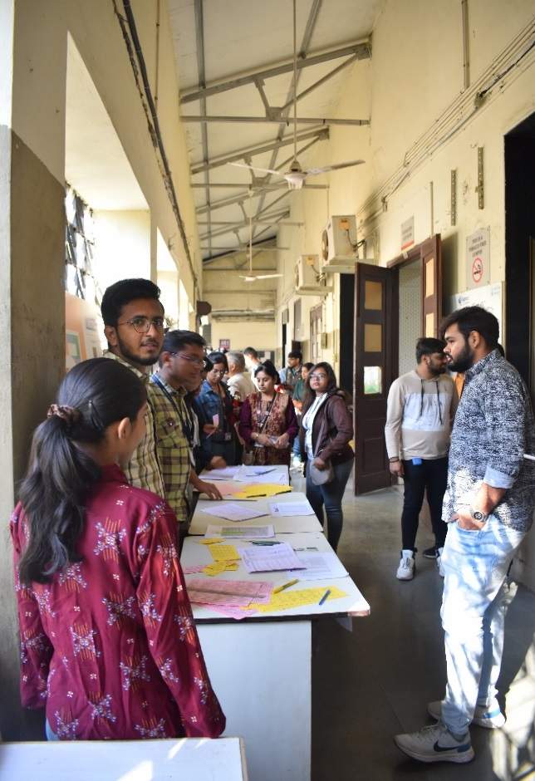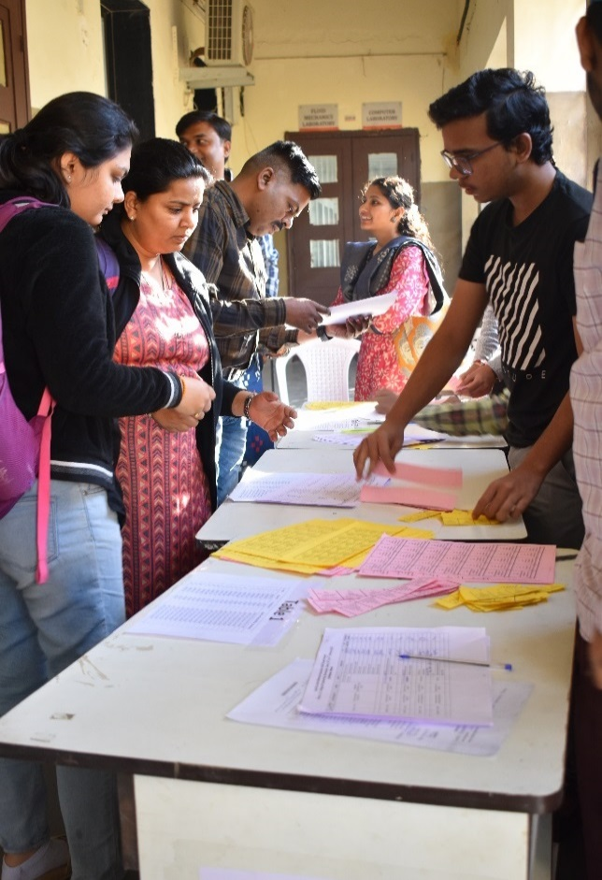
After registration and break-fast, a formal inauguration of the event was organized at WRM hall of the institute around 9:00 AM.
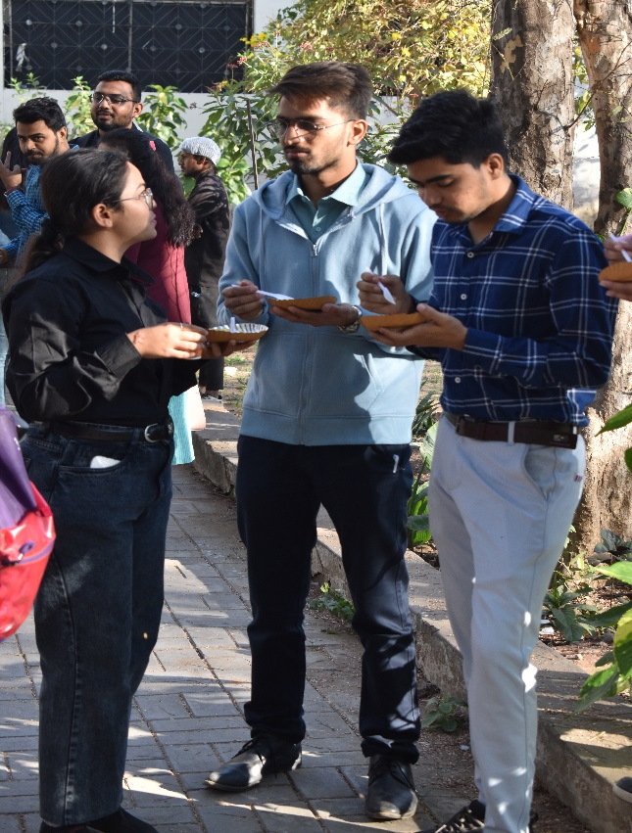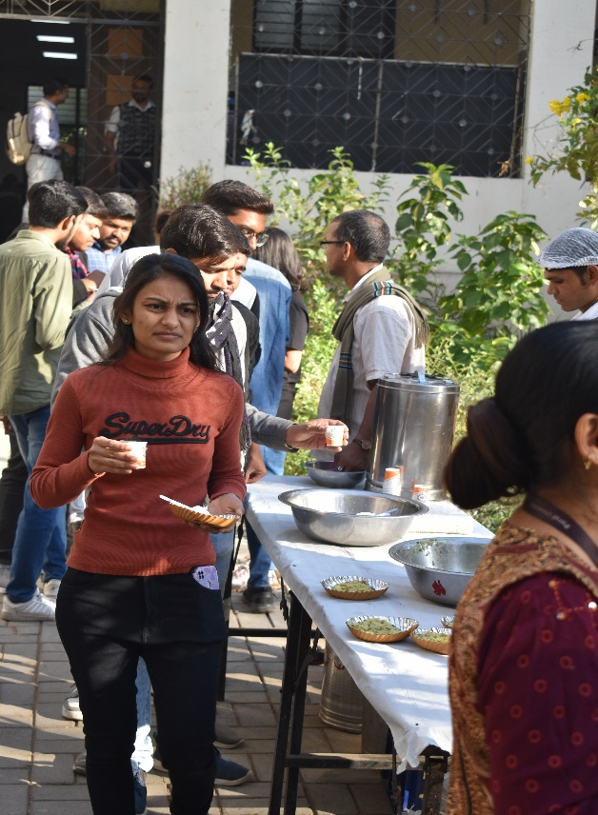
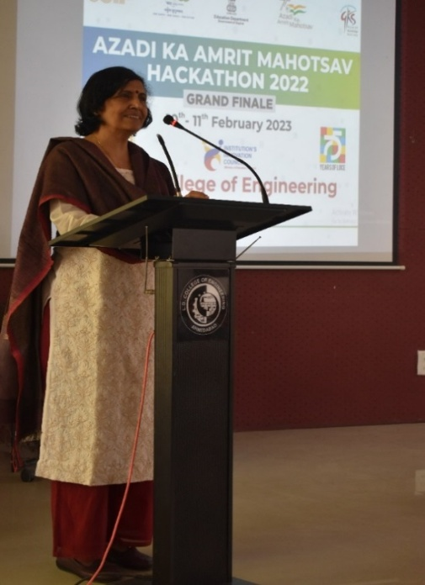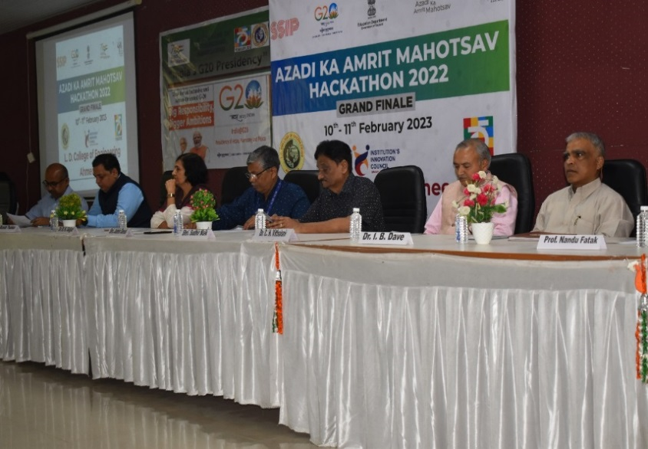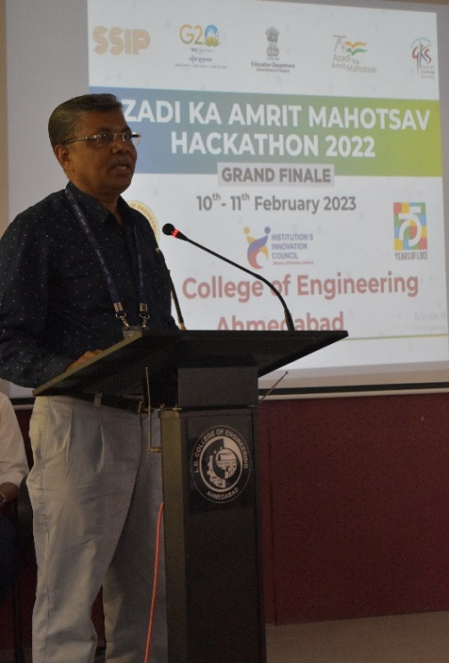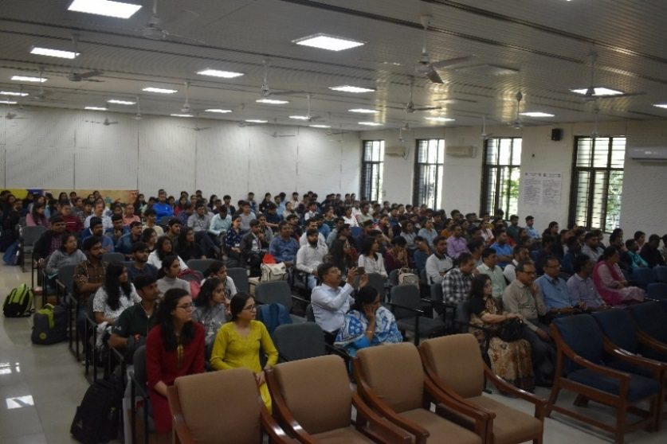
After that, the participants were allocated appropriate space with good internet connectivity and other facilities to work on the problem. The participants then started their project setup accordingly. From around 09:30 AM to 1:00 PM, participants worked on solving the defined problems and made themselves ready for presentation and demonstration. Meanwhile the jury team also had their meetings to discuss various evaluation criteria.

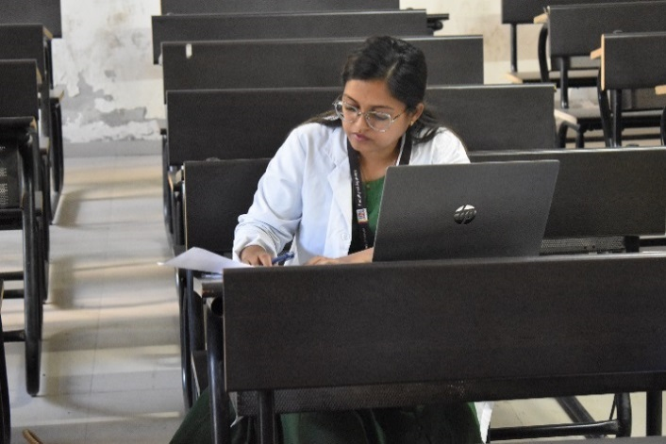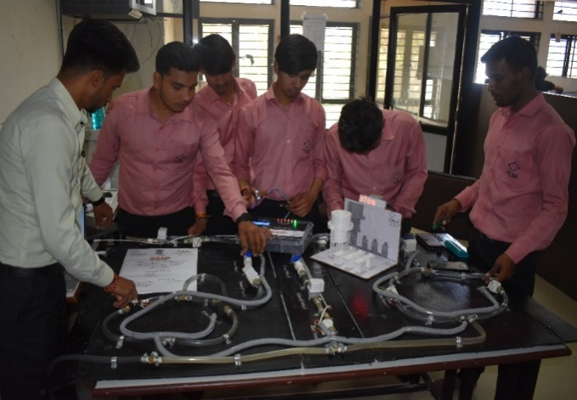
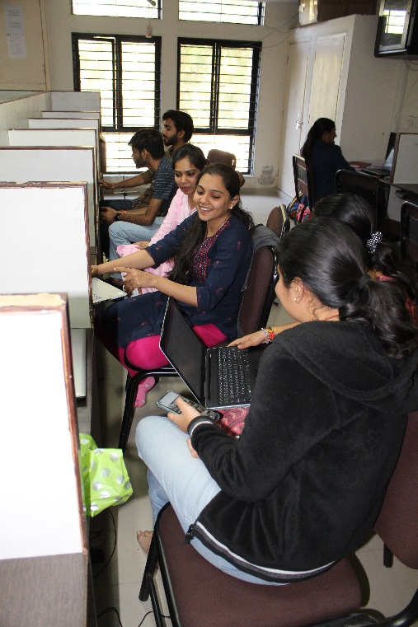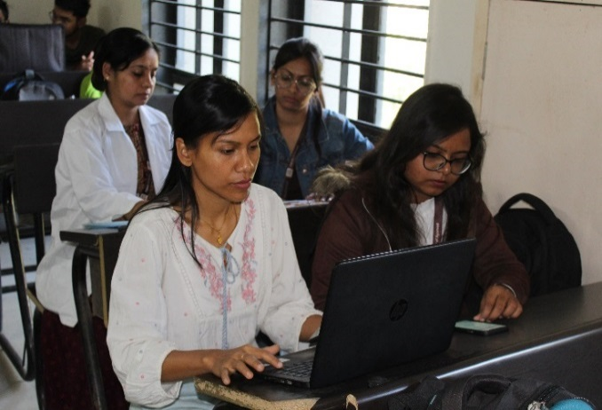
From 1:00 PM to 2:00 PM, lunch break for participants and all the stake holders was arranged with delightful food. The participants enjoyed the food.
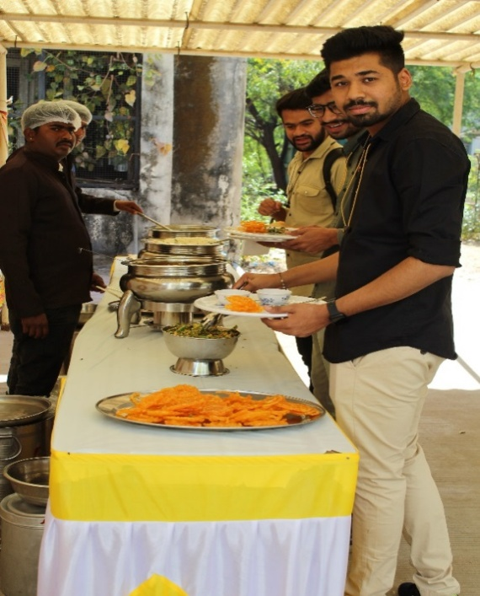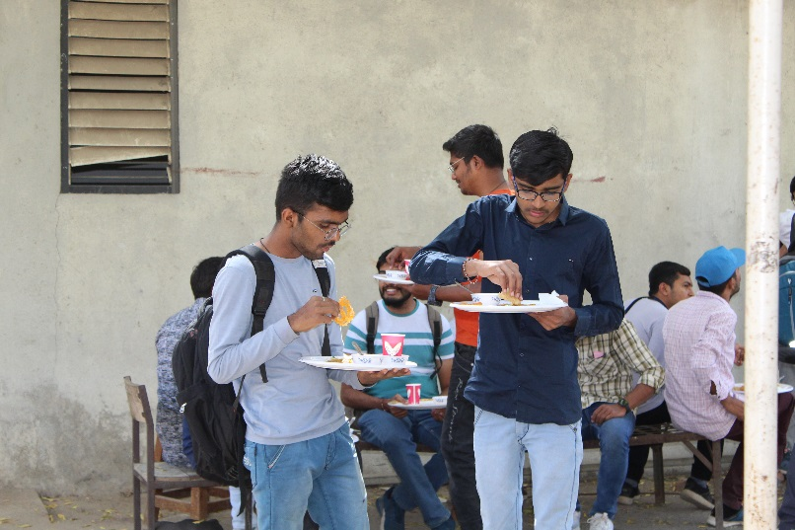
After lunch, the participants again started working on the problem. The first round of mentoring was carried out from 3:00 PM to 4:30 PM. The judges spent approximately 10 minutes with each team and gave them valuable inputs. The judges suggested necessary modification to be done by the teams. The teams then again started working on the suggestions provided by the juries upto 8:30 PM.
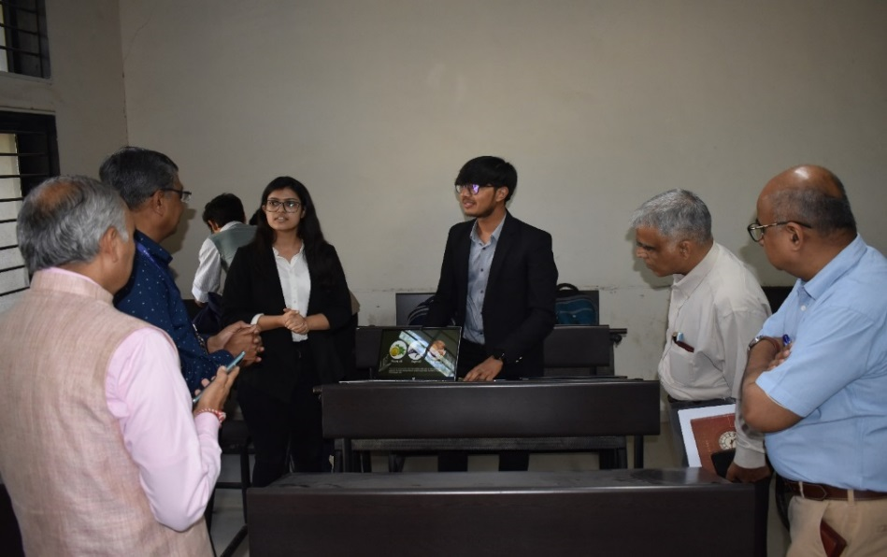
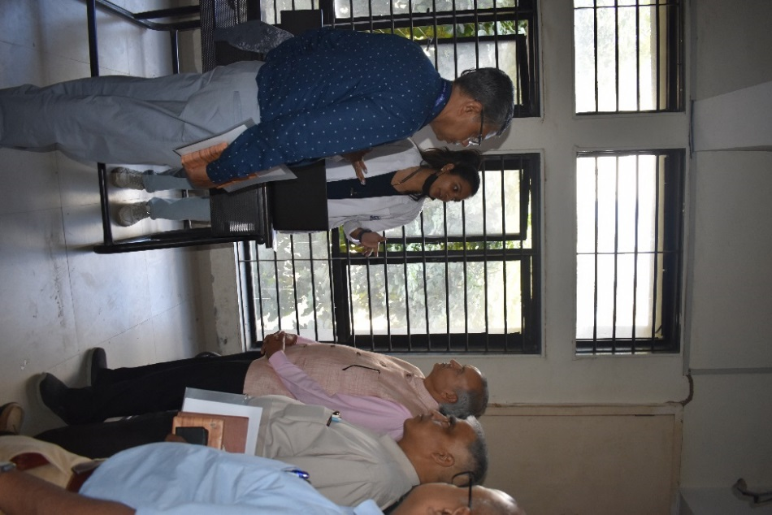
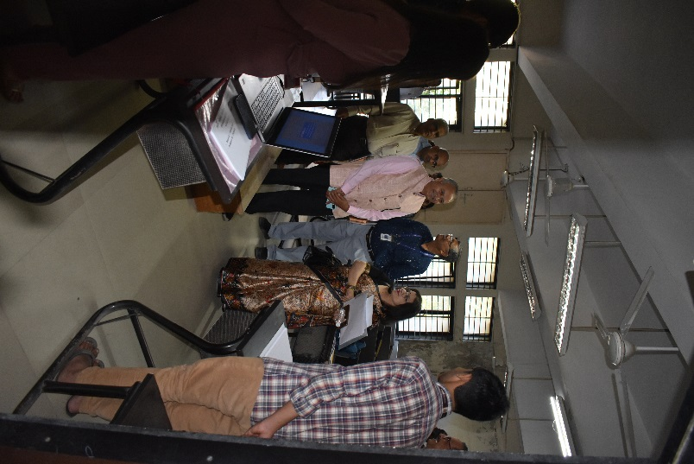
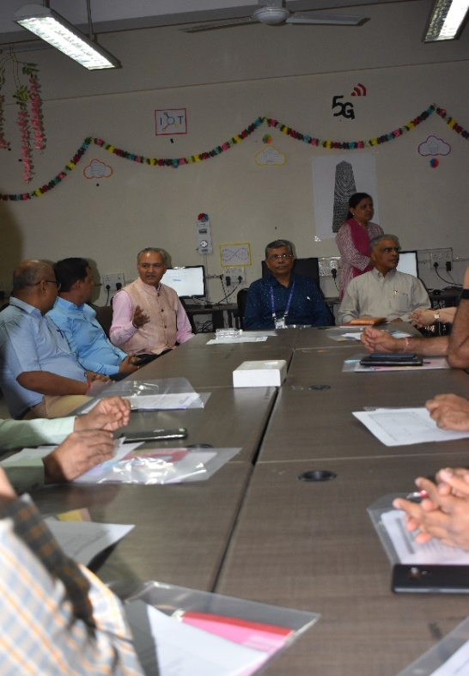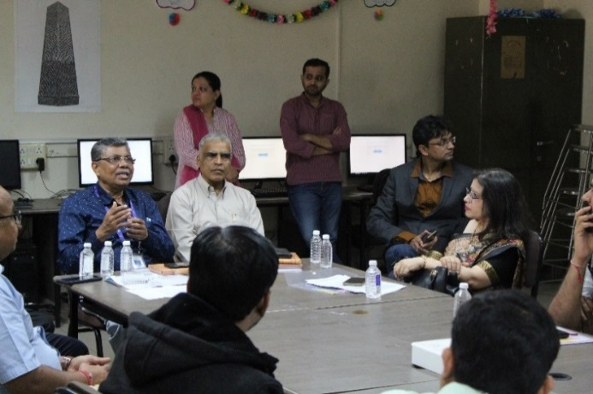
In between, there was a break for dinner from 08:30 PM to 09:30 PM. In dinner, students, mentors and jury members were served delicious and nutritious food. Thereafter, the first round of evaluation was carried out by the juries from 9:30PM to 11:00 PM. Then students continued to work on problem solution till late night. Appropriate accommodation was also provided for the requiring participants by the institute.
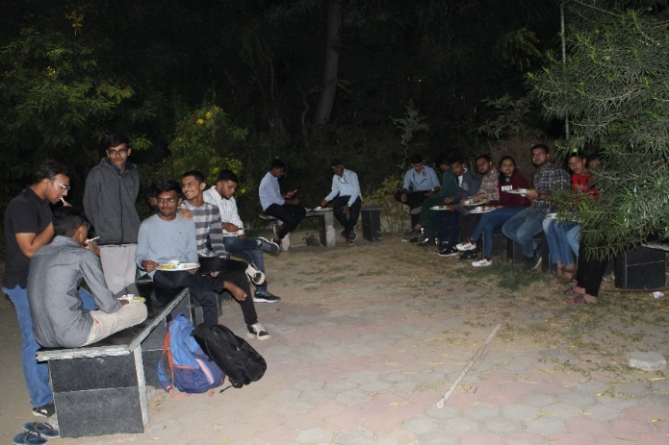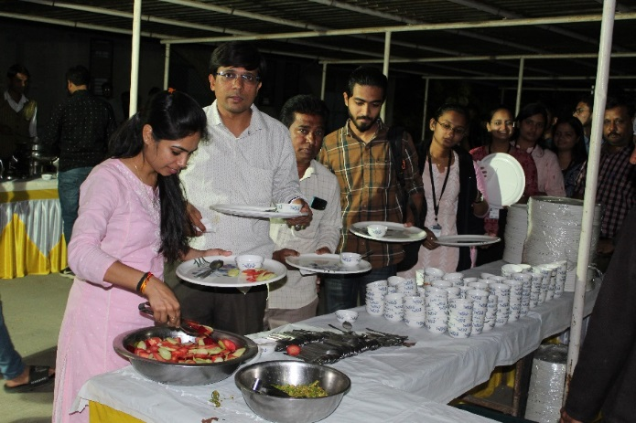

On the second day of the event problem solution works resumed at 7:30 AM. Before this, a healthy breakfast was also arranged for participants and mentors from 6:30 to 7:30 AM.
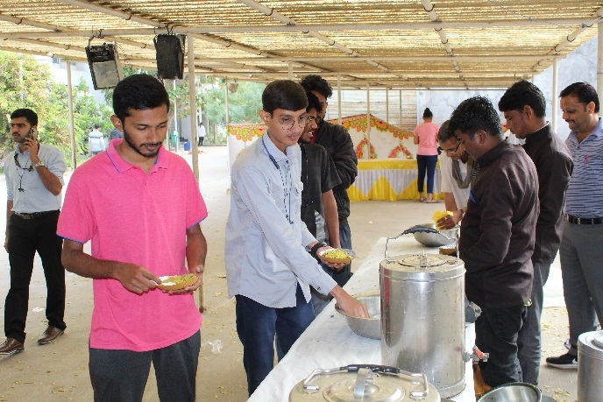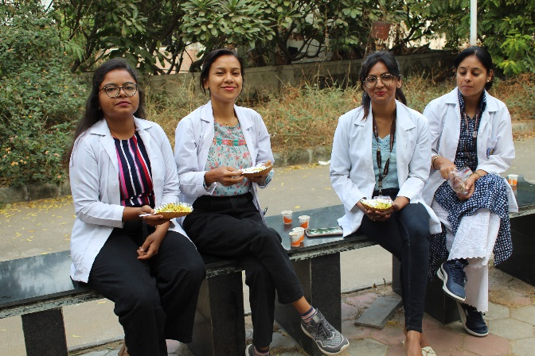

The second round of evaluation was carried out from 9:00 AM to 10:00 AM. Again juries had discussion with each team and evaluated their further development on the problem solution. Again juries provided some valuable suggestions to the teams and assigned them some further task related to the solution of the problem they have worked on.

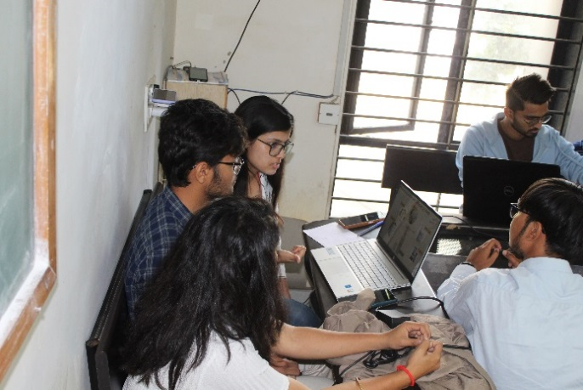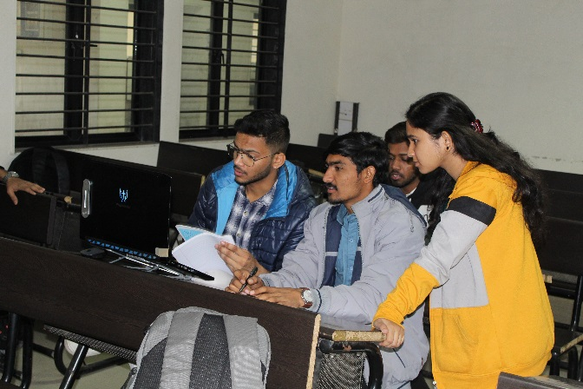
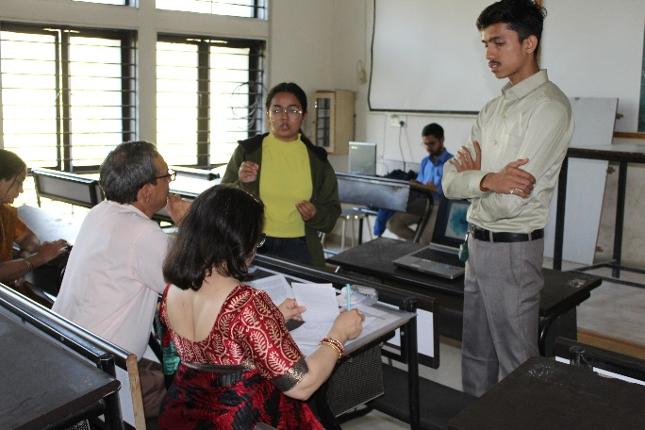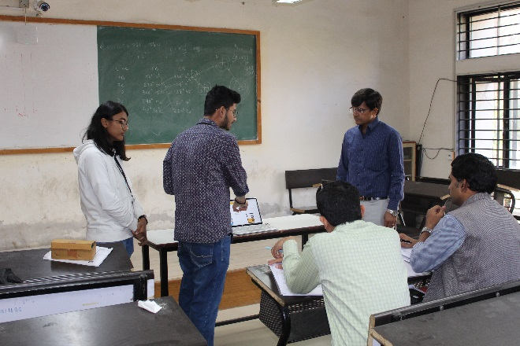
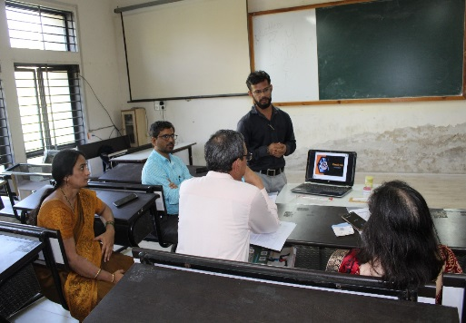

The participants again continued to work on the problems till 1:00 PM. Then there was also a lunch break for all the juries, mentors and participants from 01:00 PM to 2:00 PM.

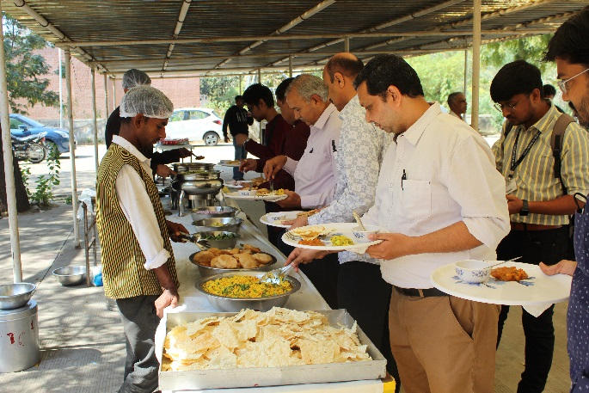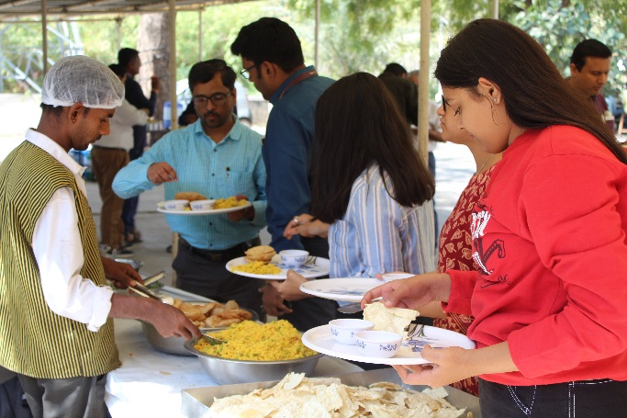
Again there was a final work session by the students from 1:00 PM to 2:00 PM. During this time, the juries also had a virtual meeting with their counterpart at other venues.
The final round of power judging was again held from 3:00 PM to 4:00 PM. Here, the teams were given five minutes time for their presentation and approximately three minutes was spent for follow-up questions by the juries with each team.
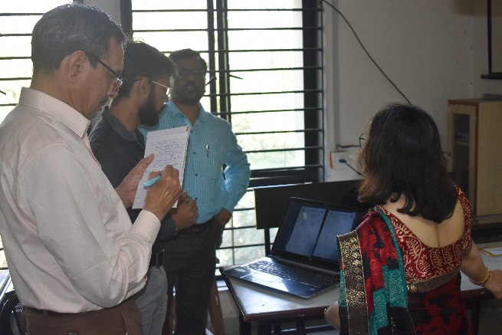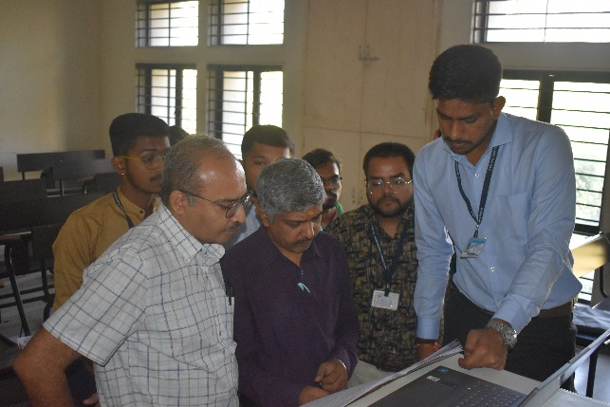
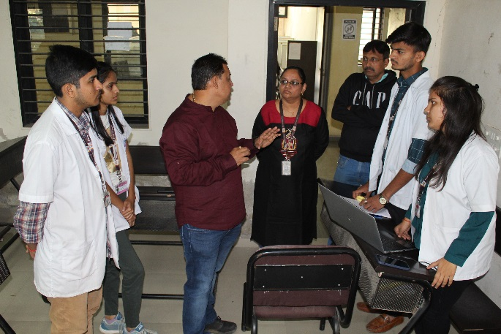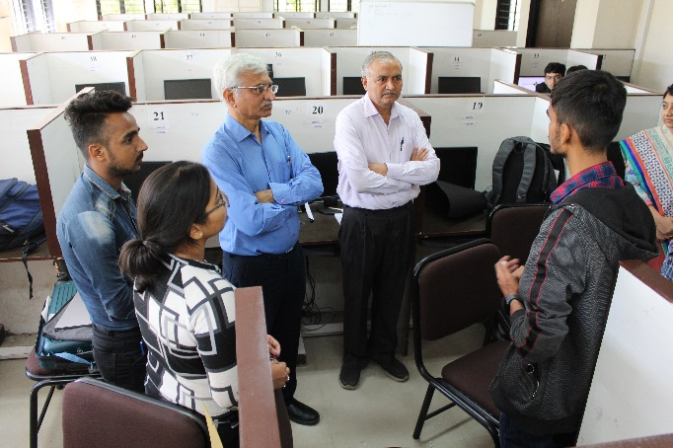

In between there was atea break for all the participants, mentors and juries.
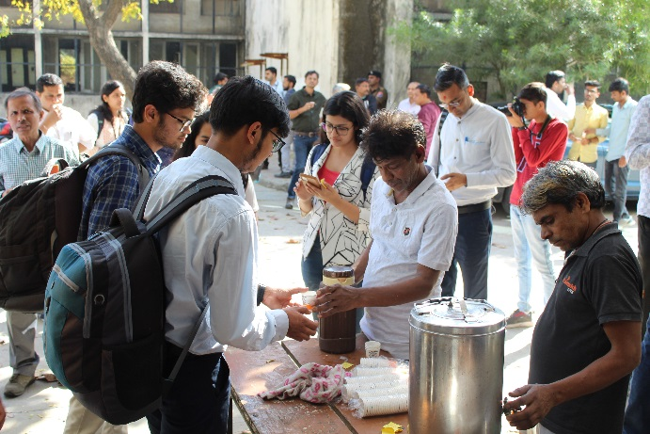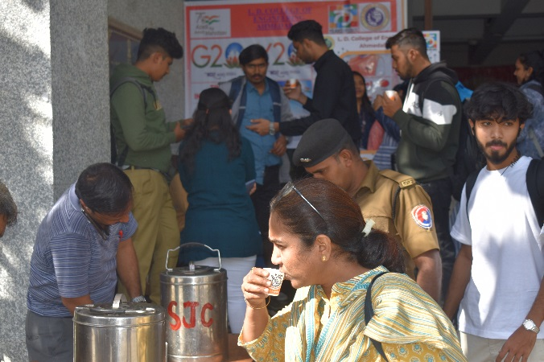
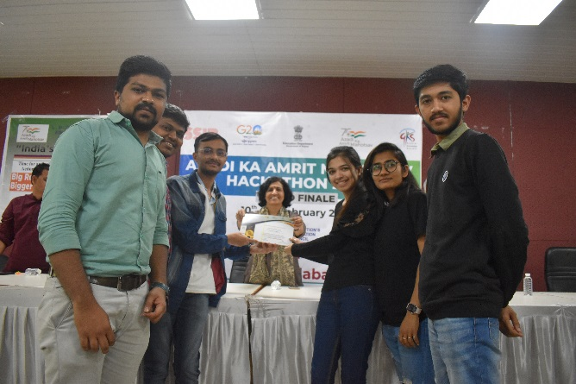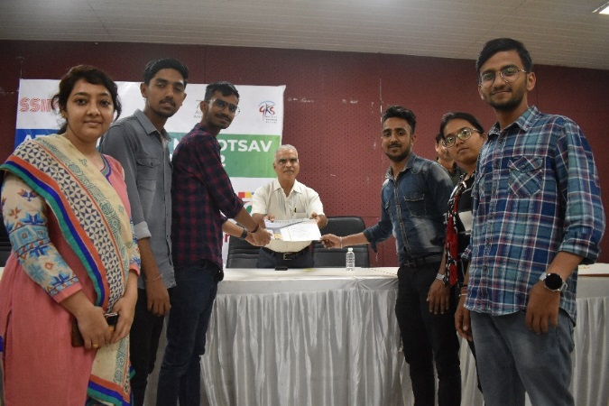
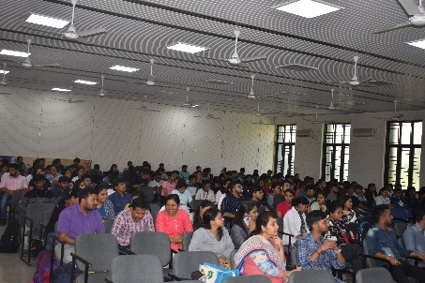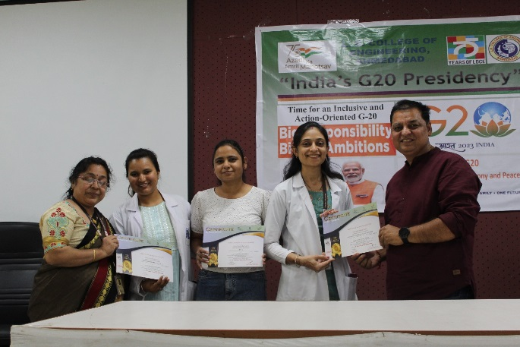
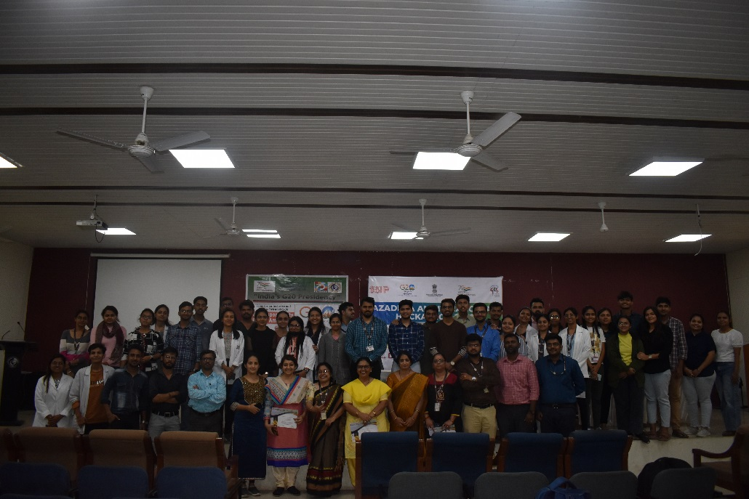
The valedictory session along with certificate distribution was organized from 4:00 PM to 5:00 PM. All the participating teams departed from the institute at around 5:00 PM.

